|  |
| --- |
|  |
| Module 4 Activity |
|  |

|  |
| --- |
| Marie Debien  3/18/2018 |

**MODULE 4 ACTIVITY**

**Module 4 Wireframe:**

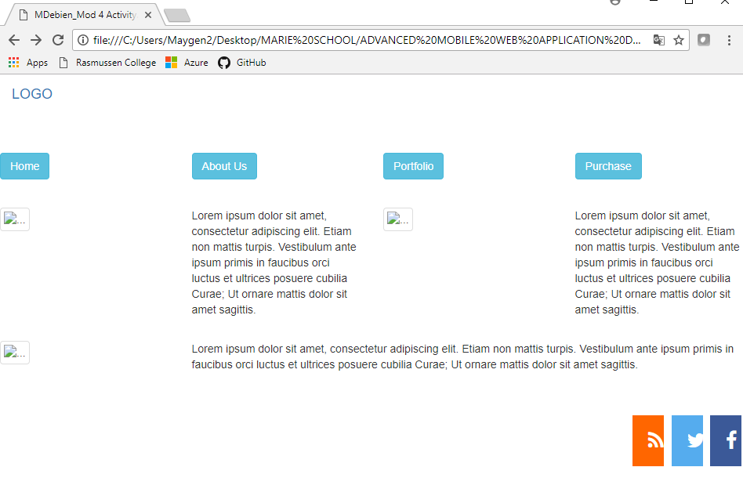

**When you click on the HOME button:**

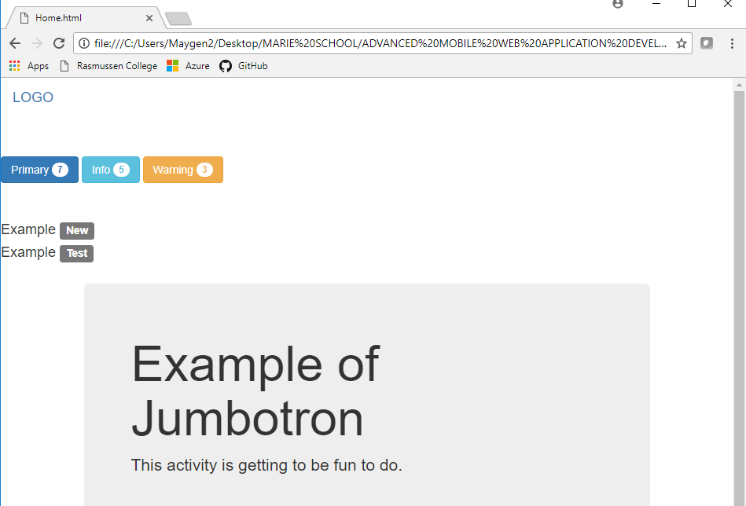

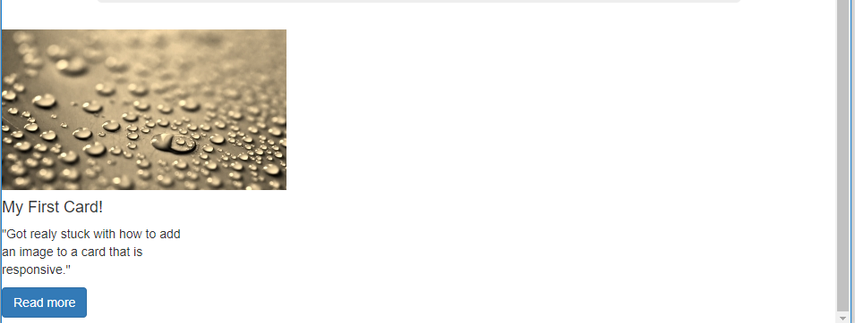

**When you click on READ MORE button:**

